Belridge Secondary College

Mathematics Specialist Unit 4

Test 4: Calculus **solutions**

**Name:** _____________________________

**Section One – calculator-free**

**1. [2, 2, 2, 4 = 10 marks]**

Determine the following definite integrals; using the substitution, when given.

1. ✓

✓

1. using the substitution,

✓

✓

1. d $x$ using the substitution, $u=$ $1+lnx$

$=\int{\frac{u^{2}}{2}}$ d ✓

✓

1. d $x = \int{{2cos}^{2}x\cos^{2}x}$ d

✓

✓

✓

✓

**2. [3, 3 = 6 marks]**

1. Express $\frac{2x-3}{(x-2)(2x-5)}$ in the form

✓

Let $x=2 ⇒$ $1= -A ⇒$ $A=-1$

Let ✓

✓

1. Hence determine $\int_{4}^{5}{\frac{2x-3}{(x-2)(2x-5)}}$ $dx$ expressing your answer as a single logarithm.

)

✓

✓

✓

**3. [4, 4 = 8 marks]**

1. Using the substitution $x=cosθ$ show that $\int_{\frac{π}{4}}^{\frac{π}{3}}{\tan^{3}}θdθ=$ $\int_{m}^{n}{\left(\frac{1}{x}-\frac{1}{x^{3}}\right)}dx$ and state the values of $m and n.$

LHS ✓

✓

✓

RHS with $m=$ $\frac{1}{\sqrt{2}}$ and ✓

1. Hence, or otherwise, evaluate $\int_{\frac{π}{4}}^{\frac{π}{3}}{\tan^{3}}θdθ$ exactly.

✓

✓

✓

✓

**End of Section One**

**Section Two – calculator-assumed**

**4. [3, 5 = 8 marks]**

The graph of the curve of equation $\sqrt{x}+2\sqrt{y}=6$ is shown below. The line of equation $x+2y=12$ is tangent to the curve at point P. The shaded region is enclosed by the curve, the tangent line and the $x$ axis.

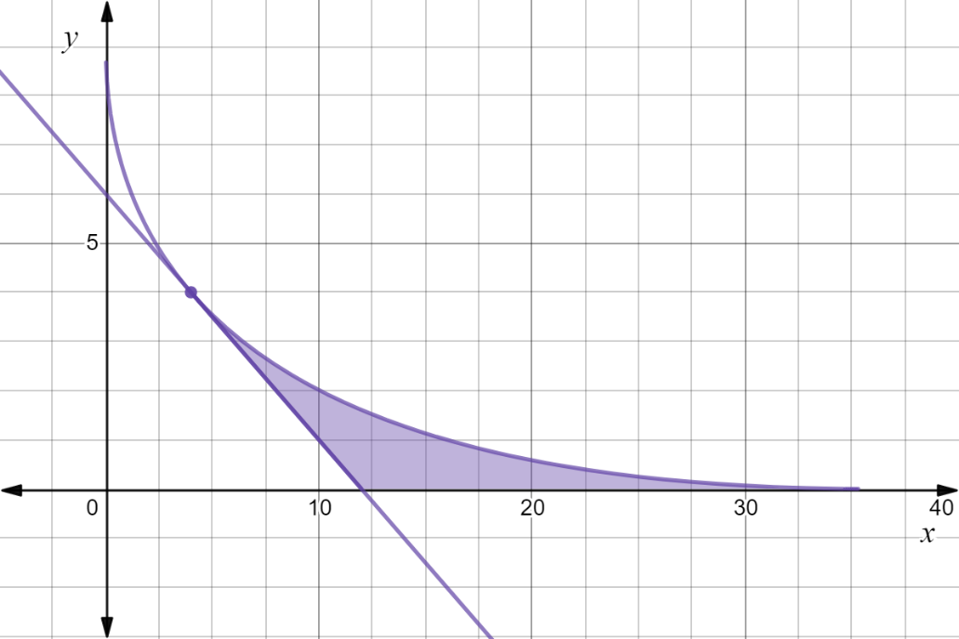

P

1. Find the co-ordinates of point P and the $x$ intercepts of the curve and the tangent line.

$P=(4,4)$ and $x$ intercepts at ✓✓✓

1. Find an integral expressionfor the area of this region in terms of
2. horizontal elementary slices

✓

✓

Area ✓

1. vertical elementary slices

✓

Area $= \int_{4}^{36}{\frac{{\left(6-\sqrt{x}\right)}^{2}}{4}}$ $dx-$ $\int_{4}^{12}{\left(6- \frac{x}{2} \right)}$ $dx$ $(=16 as a check)$

**5. [4, 4 = 8 marks]**

For the curves with equations $2y2 -9x=0$ and $y2-12x+60=0$ determine the volume of the solid formed when the region enclosed by the two curves is

1. rotated about the $y axis.$

$2y2 -9x=0⇒x=$ $\frac{2y^{2}}{9}$ and ✓

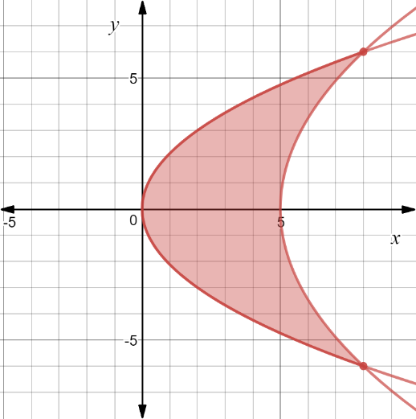

✓

✓

1. rotated about the $x$ axis

$2y2 -9x=0⇒y^{2}=$ $\frac{9x}{2}$ and ✓

✓✓

✓

**6. [5 marks]**

A bucket has a circular base of radius $r$ cm and a circular rim of radius $R$ cm. The perpendicular height of the bucket is $H$ cm. Use calculus techniques to determine, in simplest form, the volume of water, in terms of $r, R and H,$ this bucket will hold when full.

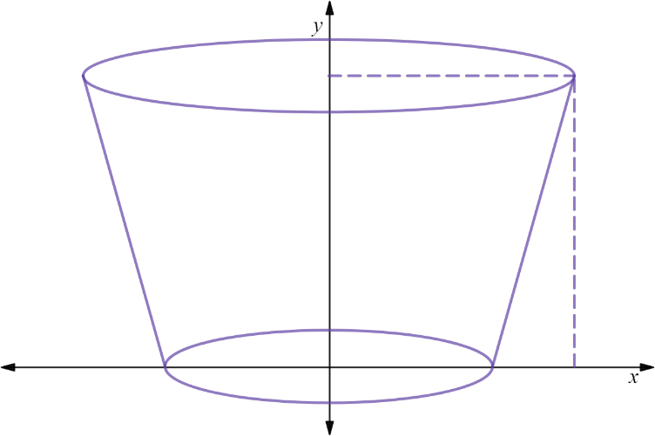

$$(R, H)$$

$$(r, 0)$$

gradient of edge of bucket ✓

equation of line ✓✓

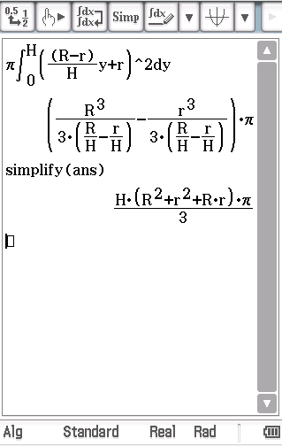

✓

✓

**7. [5 marks]**

Below is shown the uniform cross-section of a drainage canal (shaded), the bed of which is described by curves; $4y+$ $e^{5xln2}$ $=2$ and $4x+y = 2.5x^{2}$, where $x$ and $y$ are measured in metres and the $x$ axis represents the water level. If the water is flowing at the rate of $3.5 m/s$ then how many kilolitres (to the nearest kL) of water will pass by in two minutes.

Note: 1 m3 = 1kL

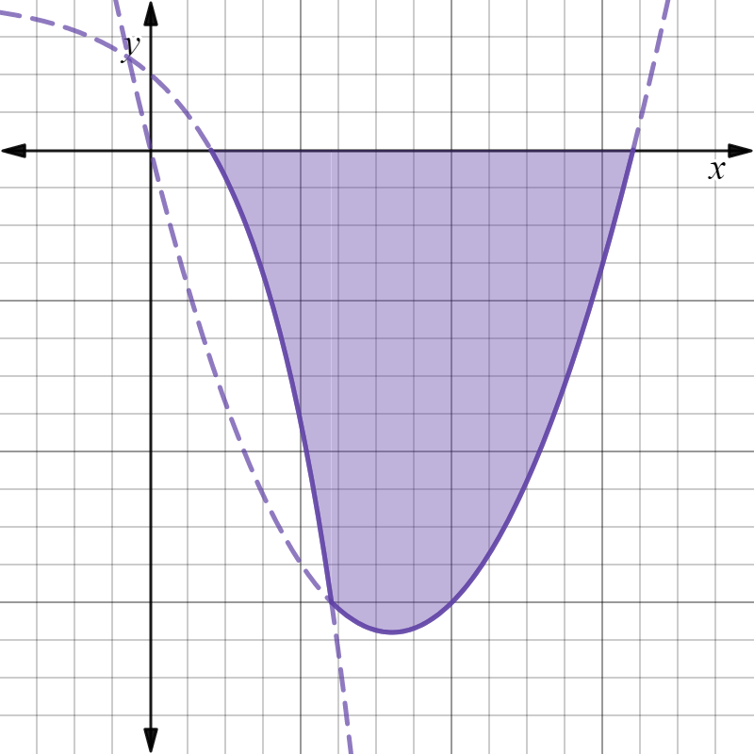

and $4x+y = 2.5x^{2} ⇒ y=2.5x^{2}-4x$

$∴$ Area ✓✓

✓

Volume of water ✓

to the nearest ✓

**8. [3, 2 = 5 marks]**

The ellipse shown has equation $\frac{x^{2}}{a^{2}}+\frac{y^{2}}{b^{2}}$ $=1$ with $a>b>0$.

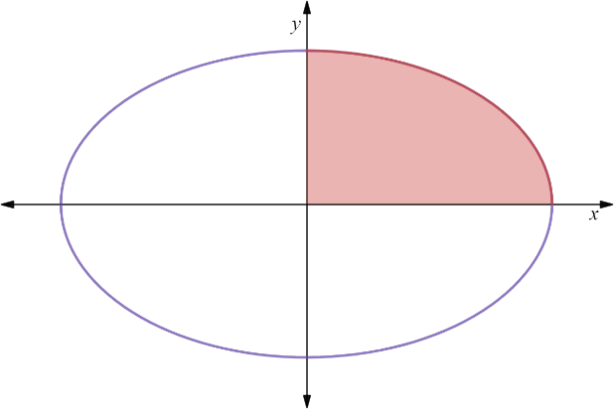

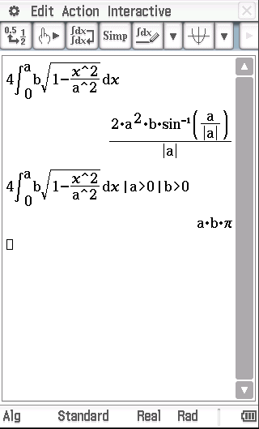Use a suitable integral to determine, in terms of $a and b$,

1. the area of the ellipse.

✓

Area ✓

✓

1. the volume of the ellipsoid formed by rotation of the ellipse about the $x$ axis.

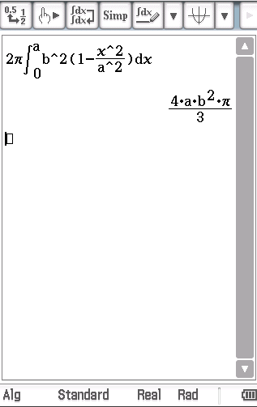

✓

✓

**End of Section Two**